Introduction: Separating Light
Sunlight, spotlights, lamps, and street lights brighten the world with light that is seen as white light. Yet a variety of colors are visible in the world—the rich green of plants, the bright red of ripe apples, the brilliant blue of the sky. Where do these colors come from?
The colors you see are all part of the visible light range of the electromagnetic spectrum. The range includes a variety of wavelengths and frequencies of light. When all these wavelengths come together, the eye sees white light.
Proving that all the colors humans see are all included in white light is easy. You can separate white light into all the individual wavelengths making up visible light.



Organize What You Learn
Use the graphic organizer to compare ideas about the separation of light in the visible light range of the electromagnetic spectrum and the response of humans and plants to those colors. Use the top box to record information that describes the visible light spectrum. Then use the left side to record details of the human response to color and the right side to record details about plant response to color.
Visible Light Review
What are the visible light portions of the electromagnetic spectrum?

Galleria

Electromagnetic spectrum: visible light

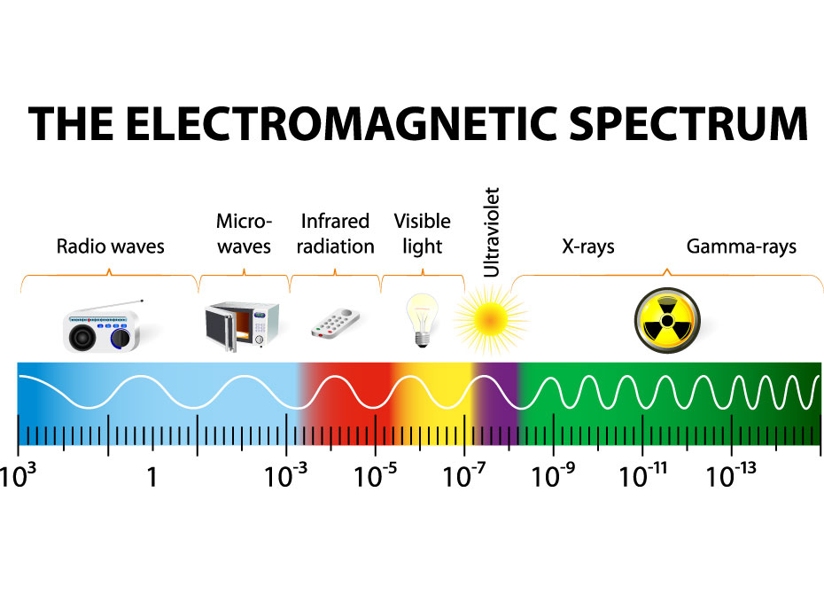
The electromagnetic spectrum

Visible light has shorter wavelengths than radio waves and infrared waves, but it has longer wavelengths than UV rays, x-rays, and gamma rays. Visible light has a higher frequency than radio waves and infrared waves, but it has lower frequency than UV rays, x-rays, and gamma rays. Visible light is a form of non-ionizing radiation. Its radiant energy is greater than radio waves and infrared waves but less than that of UV rays, x-rays, and gamma rays.

The range of visible light

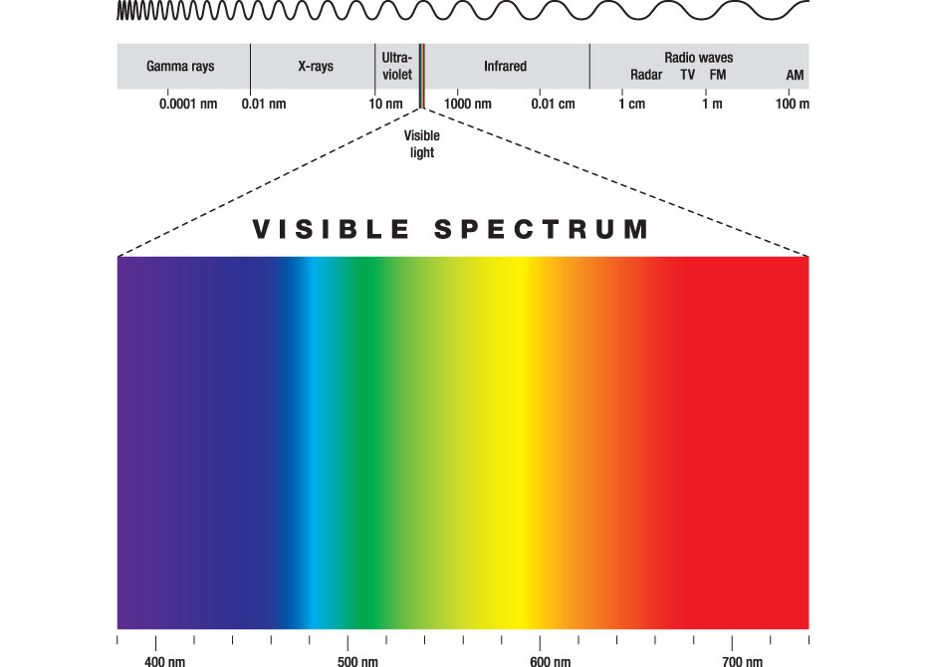
Electromagnetic Spectrum

The visible light spectrum ranges from violet, to indigo, blue, green, yellow, orange, and red. Violet has a longer wavelength and lower frequency than red light at the opposite end of the spectrum. This is the range of the electromagnetic spectrum that can be seen by the human eye.

The path of visible light

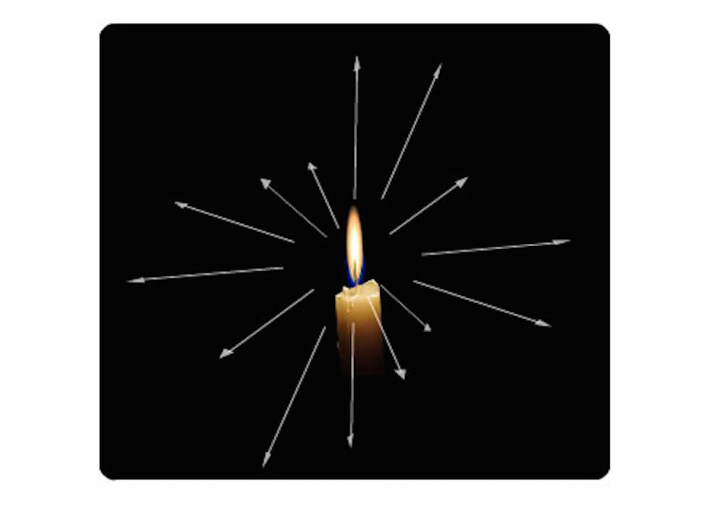
Candle with arrows pointing in all directions from the flame

Light waves, like all electromagnetic waves, travel in a straight line through a single uniform medium. Only a change in medium disturbs the direction they travel.

Natural separation of the colors in white light


Rainbow

A rainbow is the separation of white light into all its component colors. Raindrops in the atmosphere can cause light waves to bend or refract instead of traveling in straight lines.

The prism

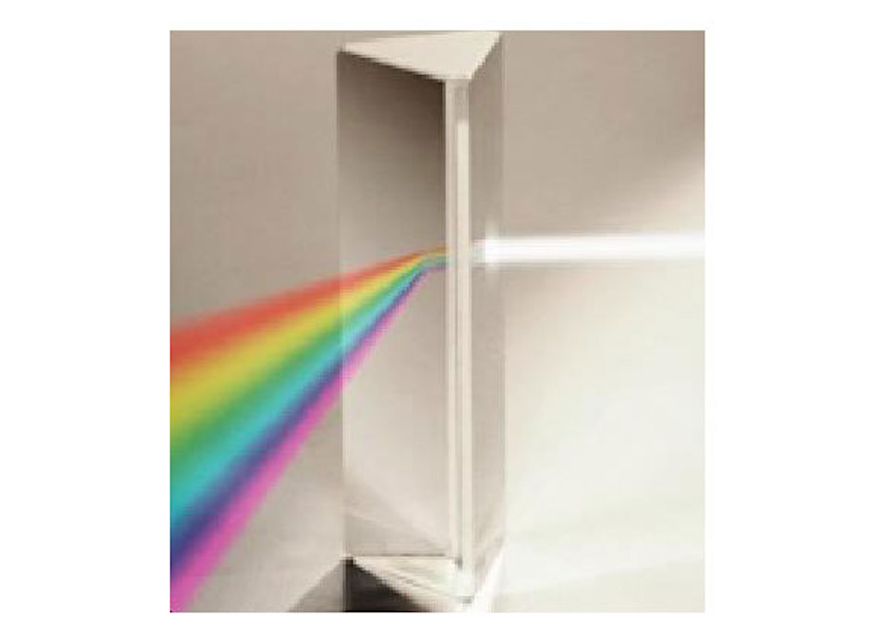
Light going through a prism

A prism is a manmade separator of white light that is a transparent object. All its surfaces are polished and flat. At least two of the flat surfaces must have an angle between them. Prisms often have triangle-shaped bases and sides that are rectangular. Isaac Newton used prisms to discover that white light was composed of many colors.

Response to Color: Humans
When white light hits an object, some wavelengths of light reflect off the surface of the object , while others are absorbed by it. Your eyes interpret the wavelength of the reflected light as color.
Human eyes detect different wavelengths of light using the layer of cells at the back of the eye called the retina . This region of the eye contains many cells called photoreceptors . The photoreceptors are light sensitive and create images by responding to light .
The eye contains two types of photoreceptors. Cones are color sensitive and rods are light sensitive but don't distinguish color. There are three types of cones . Each type responds to different wavelengths of light—short, medium, and long. By combining the information from all three types of cones, humans can see all colors of the spectrum.

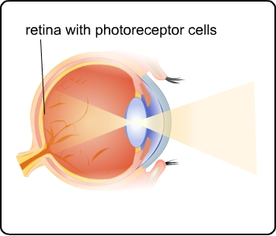

Response to Color: Plant Cells
Some cells in plants respond to different wavelength of light. However, plant cells do not use light to see. They use light to make food by way of a chemical reaction called photosynthesis .
Most plant leaves contain chlorophyll , a molecule that absorbs certain wavelengths of light. Chlorophyll absorbs a lot of red and blue light, but not much green light. Green light that is not absorbed is reflected. The photoreceptors in human eyes detect this reflected light and the brain interprets this as the color green.

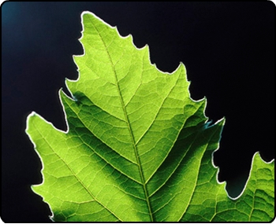

Building The Apparatus
Khianna used this illustration to guide her in setting up a light separation apparatus.
It works because water droplets in the air are nature’s grand prisms. These act like small prisms, separating white light into various wavelengths of color.

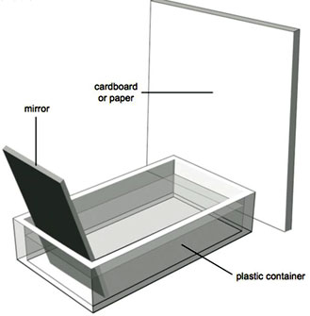

Study Club: Separating Light

Screen 1

Getting Results

Image of light separating apparatus

Khianna: I collected the materials for this experiment, which included a shallow, clear baking pan; a strong flashlight; a mirror; and thick white paper. I first placed the mirror at a 45-degree angle in the water. That’s about halfway between being completely horizontal and completely vertical. I then shined the flashlight on the mirror in the water to see if the white light separated.

Assignment: Separating Light Investigation
Use your observations to answer the questions in this assignment.

